**Spring Data JPA - Quick Example**

**Step 1:**

Go to <https://start.spring.io/> and create a maven project like

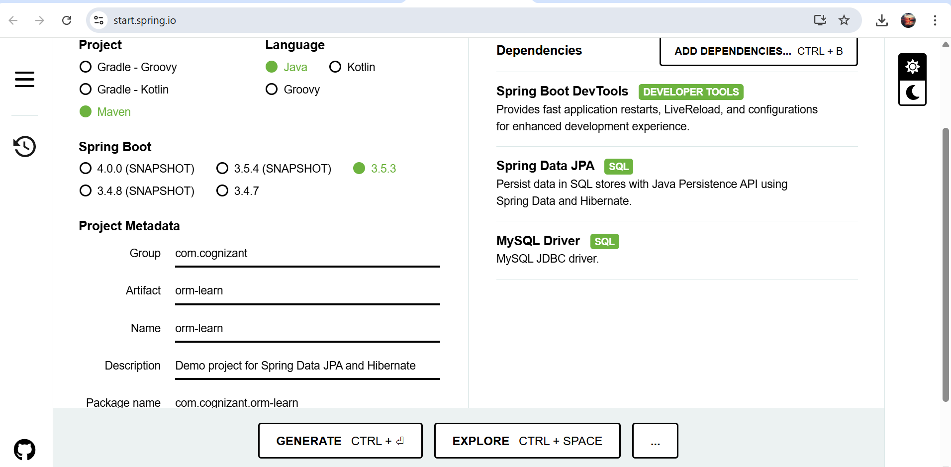

**Step 2:**

Create a package called com.cognizant.orm_learn.model after importing the maven project. And create a Country.java

package com.cognizant.orm_learn.model;

import jakarta.persistence.Column;

import jakarta.persistence.Entity;

import jakarta.persistence.Id;

import jakarta.persistence.Table;

@Entity

@Table(name = "country")

public class Country {

@Id

@Column(name = "code")

private String code;

@Column(name = "name")

private String name;

public String getCode() {

return code;

}

public void setCode(String code) {

this.code = code;

}

public String getName() {

return name;

}

public void setName(String name) {

this.name = name;

}

@Override

public String toString() {

return "Country [code=" + code + ", name=" + name + "]";

}

}

**Step 3:**

Create another package com.cognizant.orm_learn.service and create CountryService.java class

package com.cognizant.orm_learn.service;

import java.util.List;

import org.springframework.beans.factory.annotation.Autowired;

import org.springframework.stereotype.Service;

import org.springframework.transaction.annotation.Transactional;

import com.cognizant.orm_learn.model.Country;

import com.cognizant.orm_learn.repository.CountryRepository;

@Service

public class CountryService {

@Autowired

private CountryRepository countryRepository;

@Transactional

public List<Country> getAllCountries() {

return countryRepository.findAll();

}

}

**Step 5:**

Create another package called com.cognizant.orm_learn.repository and create an instance CountryRepository.java

package com.cognizant.orm_learn.repository;

import org.springframework.data.jpa.repository.JpaRepository;

import org.springframework.stereotype.Repository;

import com.cognizant.orm_learn.model.Country;

@Repository

public interface CountryRepository extends JpaRepository<Country, String> {

}

**Step 6:**

Update the application.properties

spring.datasource.driver-class-name=com.mysql.cj.jdbc.Driver

spring.datasource.url=jdbc:mysql://localhost:3306/ormlearn

spring.datasource.username=root

spring.datasource.password=root

spring.jpa.hibernate.ddl-auto=validate

spring.jpa.properties.hibernate.dialect=org.hibernate.dialect.MySQLDialect

logging.level.org.springframework=info

logging.level.com.cognizant=debug

logging.level.org.hibernate.SQL=debug

**Step 7:**

Run the java application.

**Output:**

2025-07-10T20:31:54.336+05:30 INFO 31792 --- [ restartedMain] o.h.e.t.j.p.i.JtaPlatformInitiator : HHH000489: No JTA platform available (set 'hibernate.transaction.jta.platform' to enable JTA platform integration)

2025-07-10T20:31:54.386+05:30 INFO 31792 --- [ restartedMain] j.LocalContainerEntityManagerFactoryBean : Initialized JPA EntityManagerFactory for persistence unit 'default'

2025-07-10T20:31:54.954+05:30 INFO 31792 --- [ restartedMain] o.s.b.d.a.OptionalLiveReloadServer : LiveReload server is running on port 35729

2025-07-10T20:31:54.984+05:30 INFO 31792 --- [ restartedMain] c.c.orm_learn.OrmLearnApplication : Started OrmLearnApplication in 4.75 seconds (process running for 5.32)

2025-07-10T20:31:54.990+05:30 INFO 31792 --- [ restartedMain] c.c.orm_learn.OrmLearnApplication : Inside main

2025-07-10T20:31:54.991+05:30 INFO 31792 --- [ restartedMain] c.c.orm_learn.OrmLearnApplication : Start

2025-07-10T20:31:55.229+05:30 DEBUG 31792 --- [ restartedMain] org.hibernate.SQL : select c1_0.code,c1_0.name from country c1_0

2025-07-10T20:31:55.285+05:30 DEBUG 31792 --- [ restartedMain] c.c.orm_learn.OrmLearnApplication : countries=[Country [code=IN, name=India], Country [code=UK, name=United Kingdom], Country [code=US, name=United States of America]]

2025-07-10T20:31:55.285+05:30 INFO 31792 --- [ restartedMain] c.c.orm_learn.OrmLearnApplication : End

2025-07-10T20:31:55.295+05:30 INFO 31792 --- [ionShutdownHook] j.LocalContainerEntityManagerFactoryBean : Closing JPA EntityManagerFactory for persistence unit 'default'

2025-07-10T20:31:55.300+05:30 INFO 31792 --- [ionShutdownHook] com.zaxxer.hikari.HikariDataSource : HikariPool-1 - Shutdown initiated...

2025-07-10T20:31:55.311+05:30 INFO 31792 --- [ionShutdownHook] com.zaxxer.hikari.HikariDataSource : HikariPool-1 - Shutdown completed.